**Title**:

**"EfficientNet-Enhanced Breast Cancer Detection: A Deep Learning Approach for Precision Medicine"**

**Abstract** :   
  
In this modern developing world, breast cancer still remains a challenging issue to fight against.It’s a significant global health challenge. Women of various ages are still suffering from this deadly disease. If not cured, it leads to the advanced stage. Studies say that advanced level breast cancer might not even be curable . So , detecting it in the early stages is a very important thing to do. In recent times, deep learning techniques are being used on medical images analysis and these deep learning techniques are doing remarkable jobs. This study aims to explore the idea of using a swin transformer model on a curated Breast Imaging Subset DDSM Dataset . The unique hierarchy of Swin Transformer's attention mechanism and its capabilities of parallel processing make it best fit for handling complex relationships within medical images. Our proposed model is intended to not only automatically identify but also classify suspicious regions indicative of breast cancer. The model undergoes intensive training and validation on multiple datasets, optimizing its capacity to generalize across various patient demographics and imaging situations. Our experimental results illustrate the usefulness of the Swin Transformer in obtaining competitive performance compared to classic convolutional neural networks (CNNs) and other transformer-based architectures . As the area of deep learning continues to evolve, this research underlines the promise of transformer topologies in altering the landscape of medical image analysis for increased early diagnosis and intervention in breast cancer.

**Introduction :**

Breast cancer is one of the most common diseases in ladies. This disease happens gradually by the mutation of a breast cell rapidly. This cell later on becomes a cancerous cell which multiplies and ends up forming a tumor. According to the IARC - International Agency for Research on cancer, about 2.26 million women worldwide were diagnosed with breast cancer. Unfortunately 685k women died from this disease.

Identification of breast cancer in an early stage is important to reduce the death toll. The histopathologists use the biopsy to determine whether a cell is cancerous or not which is time consuming.Moreover, the conclusion is totally dependent on the histopathologist’s capability to search for strange malignant cells under a magnifying lens.

For a more subtle and accurate result, we will be using deep learning convolutional networks to diagnose breast cancer. The Efficient Net 2 model has more accuracy in learning the cell core types and their structure with the help of histology. In this paper, we are going to show thorough analysis of different models and experimental analysis with Efficient Net 2 to achieve a higher accuracy.

**Literature Review:**

1. **Paper name:** Breast cancer detection using artificial intelligence techniques: A systematic literature review

The comprehensive literature evaluation conducted by Bou Nassif et al. emphasizes the pivotal significance of artificial intelligence (AI) in the identification of breast cancer. The report emphasizes the gravity of breast cancer and the growing utilization of AI and deep learning techniques for early detection. The paper specifically examines the use of artificial intelligence, with a particular emphasis on deep learning, in the fields of genetic sequencing and histopathological imaging. The text highlights the widespread use of machine learning models and the very limited investigation into deep learning. The authors present research inquiries on the efficacy of deep learning, the factors that impact classification, the datasets used, and the comparison between gene sequencing and imaging. The methodology outlines the process of selecting relevant literature from Scopus, and the findings highlight the dominant role of CNN. The research lacks exploration of underused attention processes and extensive assessment criteria are required. The report finishes by outlining potential areas for future research and discussing the ethical implications, offering useful insights and suggestions for further investigation in the field of breast cancer detection.

**2) Name** : Breast cancer detection using deep learning: Datasets, methods, and challenges ahead

The study examines the crucial matter of breast cancer, emphasizing its frequency and classification into benign, in situ carcinoma, and invasive carcinoma. Prioritizing early detection is crucial for achieving successful treatment outcomes, although conventional manual screening techniques frequently result in inaccuracies. The introduction of computer-aided detection (CAD) systems was followed by the use of artificial intelligence (AI), namely deep learning, to automate the analysis of imaging modalities including mammography and histology due to constraints. The research examines several imaging techniques, datasets, and contemporary deep learning models (from 2019 to 2022) used in the analysis of breast cancer. The challenges of dataset scarcity and model interpretability are tackled. Although there have been improvements, the study emphasizes the need for more research to improve the practical effectiveness of deep learning in the detection and treatment of breast cancer.

3) **Paper Name** : Breast cancer detection based on thermographic images using machine learning and deep learning algorithms

The study specifically addresses breast carcinoma, which is the primary cause of cancer-related fatalities on a global scale. It emphasizes the significance of identifying a problem at an early stage in order to get better results. The study suggests utilizing a Computer-Aided Diagnosis (CAD) technique that incorporates Convolutional Neural Network (CNN), Support Vector Machine (SVM), and Random Forest classifiers to classify patients into three categories: cancer, absence of cancer, and non-cancerous. The researchers investigate the influence of preprocessing mammography pictures on the accuracy of classification. The introduction provides an overview of the widespread occurrence and importance of breast cancer, emphasizing the necessity for sophisticated detection techniques. The suggested method employs Convolutional Neural Networks (CNN) to identify breast cancer using thermal imaging, achieving a remarkable accuracy of 99.65%. Comparisons of CNN, SVM, and Random Forest indicate that CNN surpasses the others in terms of accuracy, precision, and data usage. The study indicates the possibility of utilizing modern computer-aided design (CAD) systems for a wider range of problem-solving applications in the field of medical imaging.

4) **Name** : Microwave Imaging for Early Breast Cancer Detection: Current State, Challenges, and Future Directions

The article examines Microwave Imaging (MWI) as a potentially effective method for detecting breast cancer at an early stage. The text presents a comprehensive summary of MWI methods, with a particular focus on their noninvasive and cost-effective characteristics. The review discusses the dielectric characteristics of breast tissues, including the differences between normal and malignant tissues. It also addresses the obstacles that Microwave Imaging (MWI) faces, such as antenna coupling and frequency bandwidth selection. The study emphasizes the necessity of continuous research and development to fully exploit the potential of MWI in clinical applications, despite presenting encouraging outcomes. It suggests future options such as hybrid systems and millimeter-wave imaging.

5) **Name** : Microwave Imaging for Early Breast Cancer Detection: Current State, Challenges, and Future Directions

The article examines Microwave Imaging (MWI) as a potentially effective method for detecting breast cancer at an early stage. The text presents a comprehensive summary of MWI methods, with a particular focus on their noninvasive and cost-effective characteristics. The review discusses the dielectric characteristics of breast tissues, including the differences between normal and malignant tissues. It also addresses the obstacles that Microwave Imaging (MWI) faces, such as antenna coupling and frequency bandwidth selection. The study emphasizes the necessity of continuous research and development to fully exploit the potential of MWI in clinical applications, despite presenting encouraging outcomes. It suggests future options such as hybrid systems and millimeter-wave imaging.

6) **Name** :Global challenges in breast cancer detection and treatment

The article discusses the worldwide importance of breast cancer, with a focus on its effects on disadvantaged people in nations with lower incomes. The statement emphasizes the inequalities in healthcare infrastructure, delayed detection of diseases at advanced stages, and restricted availability of essential medical services. It advocates for the implementation of cost-efficient approaches to optimize resource use. The prevalence of breast cancer is a serious issue, with forecasts suggesting a substantial rise in both the number of cases and fatalities in low- and middle-income countries (LMIC) in the forthcoming decades. The essay emphasizes the need of customized methods for identifying issues at an early stage, taking into account the constraints of screening programs in settings with low resources. Furthermore, it highlights the significance of prompt availability of surgery, radiation, and systemic therapies, acknowledging the difficulties in allocating resources and prioritizing healthcare. The text discusses the wider implications of enhancing breast cancer control on women's well-being and society, emphasizing the need for joint endeavors to tackle disparities and improve healthcare outcomes in low- and middle-income countries (LMIC). The result underscores the need for proactive engagement, cooperation among stakeholders, and the emphasis of early detection and prompt intervention as crucial elements of successful breast cancer management programs.

**Materials And Methods:**

This study has been carried out for detecting the presence of breast cancer. Fig- 1 shows the suggested frameworks. In the first place , images were taken from the dataset and went through the pre-processing to remove irrelevant sections from each image. Then these were augmented to increase the number of images in the dataset. In the next stage, the pre-processed image dataset was used to train the desired model obtained by using the weights of the pre-trained model. In the final stage, images were classified into two categories , images with breast cancer and the images with no breast cancer.

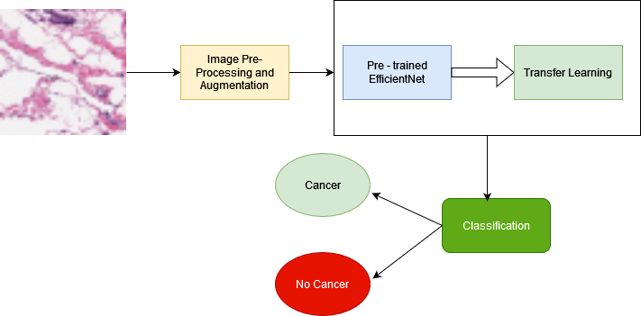

**Image Dataset:**

The image dataset that was used in this proposed method was the Breast Histopathology Images dataset collected from Kaggle. The original dataset consisted of 162 whole mount slide images of Breast Cancer (BCa) specimens scanned at 40x. From that, 277,524 patches of size 50 x 50 were extracted (198,738 IDC negative and 78,786 IDC positive). Each patch’s file name is of the format: u_xX_yY_classC.png — > example 10253_idx5_x1351_y1101_class0.png . Where u is the patient ID (10253_idx5), X is the x-coordinate of where this patch was cropped from, Y is the y-coordinate of where this patch was cropped from, and C indicates the class where 0 is non-IDC and 1 is IDC.   
  
**Pre-Processing:**

First of all, it is necessary to crop the irrelevant areas and keep only the relevant parts of the image. After loading the dataset, we converted the images to grayscale and slightly blurred. Then we converted the images to binary images using thresholding. Thresholding allows for segmenting the scanned region from the rest of the spaces.

We have used data augmentation to increase the images count. In the data

In The Augmentation section,we performed random transformations and various copies of an original image were created but with different scaling, orientation, and so on. Augmenting the dataset helped to increase the model accuracy.In the data augmentation performed by us, we have used 8 augmentation strategies which are rotation,horizontal shifts, vertical shifts, scaling, shearing, brightness, and horizontal and vertical flipping. The dataset was subdivided into three sets. Training , Testing and Validation.

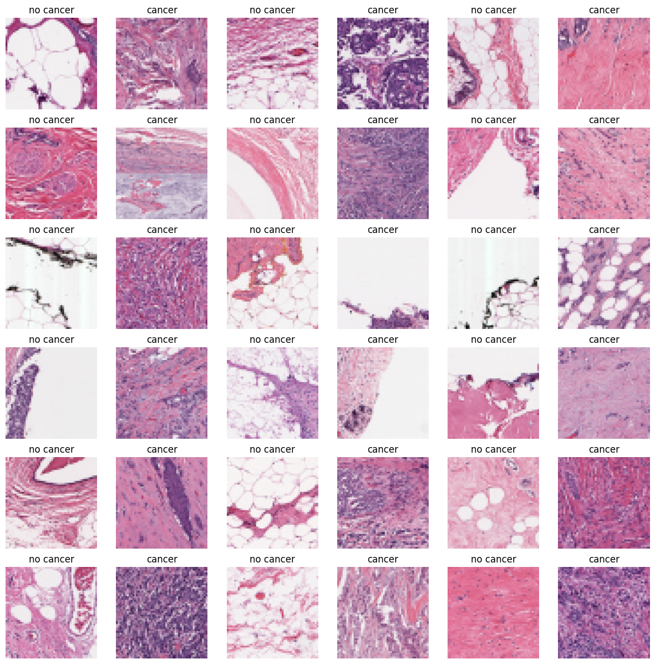

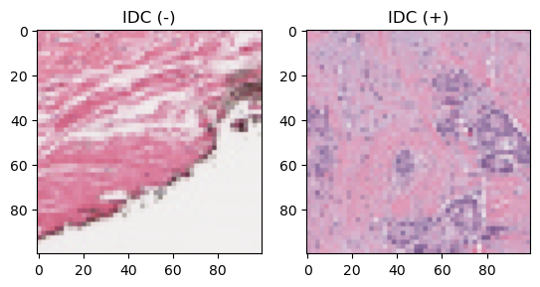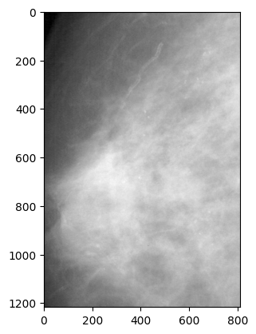

**CNN :**

Convolutional Neural Network is one of the most recognized transfer learning models. CNN is a class of neural networks in deep learning that takes images input and assigns bias and weight to a variety of objects in the picture for classification among one another . CNN reduces an image into a form that

is easier to process without compromising the relevant and prominent features required for an accurate prediction.

CNN has 3 major components:

1. A convolutional layer extracts the low level and high level attributes. Now the first convolutional layer is supervised for drawing out low level attributes and as we keep adding more convolutional layers the architecture is able to mine the high level attributes as well.
2. A pooling layer is added to reduce the computing power to execute the data using reduction of dimensionality, in which the spatial size of the extracted feature is reduced.
3. After applying the convolutional and pooling layer the model is successfully trained to understand the features. The final output is flattened and fed to a Fully Connected (FC) layer to classify images into different classes.

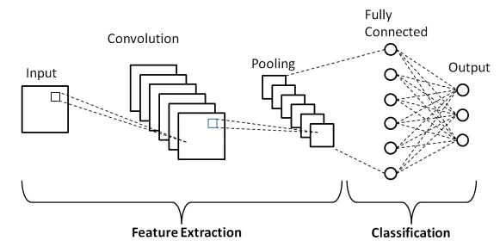

**EfficientNet Architecture:**

A variety of pre-trained models like VGG-16, ResNet50, and Inception V3 have been used in several fields for image classification. In 2019 a CNN architecture called EfficientNet [26] was introduced which uses compound coefficients for effective scaling. The architecture scales up the dimension of width, resolution and depth of resources available in a constant ratio without compromising the efficiency of the model. By using the AutoML MNAS framework for neural architecture search a new baseline network was developed on which the compound scaling method is dependent that improves both the accuracy and efficiency (FLOPS). This architecture uses mobile inverted bottleneck convolution (MBConv). With constant use of the compound scaling technique to scale up the baseline a family of models was obtained (EfficientNet-B1 to EfficientNet-B7)

.

In this paper we have used EffecientNet-B2 for Breast Cancer detection using histopathology images dataset. After the pre-processing and augmentation of the images, the weights of the EfficientNet-B2 were pre-trained on the Image-Net data bank and were used for better training of the model. We added a global max-pooling layer followed by a dropout operation with a rate of 0.2 to prevent over-fitting. Sigmoid was used as the activation function which applies a non-linear transformation to the input. In the fully connected (FC) layer loss function also called the error function is used to calculate the prediction error

of the network. We have used the binary cross-entropy loss function.

We have updated the weights of the layers using Adaptive moment estimation (Adam), an optimizer that computes the adaptive learning rate of each parameter. We run each method for 150 epochs.

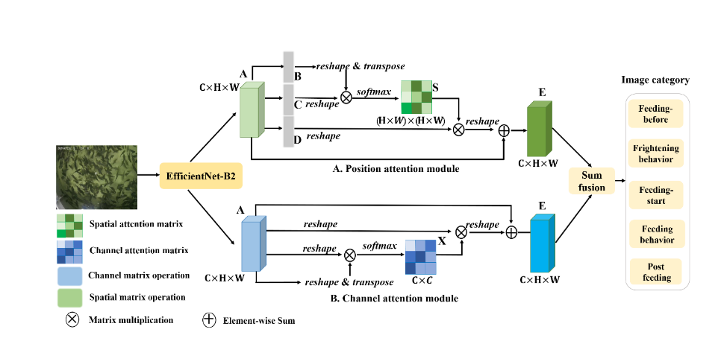

**Experiment Results :**

Three sets of experiments were carried out for breast cancer detection using the histopathology images dataset. In each set EfficientNet were utilized to classify the presence of cancer. One of the most important metrics used for the evaluation of a model’s performance is the confusion matrix since other evaluation metrics can be derived from this table.

A confusion matrix is a performance measurement tool used in machine learning and statistics, particularly in classification problems. It allows the visualization of the performance of an algorithm by comparing its predictions to the actual values. The matrix is especially useful when assessing the performance of a classification model on a dataset where the true class labels are known.The confusion matrix is evaluated using four performance measures: True negative (TN), False positive (FP), False negative (FN), True positive (TP). Now TN reflects the number of MR pictures with no cancer which was correctly classified as no cancer. The FP reflects the number of MR images with no cancer that was misclassified as having the presence of cancer. The TP reflects the number of MR images with the presence of cancer that was correctly classified as having the presence of cancer. The FN reflects the number of images with the presence of cancer that was misclassified as having no cancer.

Accuracy: It gives us the fraction of predictions our model got right. It is the ratio of the number of accurate predictions to the entire number of predictions.

Accuracy = (TP + TN) / (TP + TN + FP + FN)

Sensitivity (Recall): It is the proportion of actual positives that got predicted correctly as positives.

Sensitivity/ Recall = TP / (TP + FN)

Precision: It gives the fraction of correctly identified positives out of all predicted positives.

Precision = TP / (TP +FP)

F1 score: It is the harmonic mean of precision and recall of the model. It considers both precision and recall for

computation.

F1 score = (2 * Precision * Recall) / (Precision + Recall)

Specificity: It is the proportion of actual negatives that got predicted correctly as negatives.

Specificity = TN / (TN + FP)

In the experiments, the weights of the pre-trained system EfficientNet-B2 were used. By training the network with the system, the accuracy and loss curves obtained are depicted in Figure below.As it can be shown from Figure the training accuracy of the system is 99.74 %.The accuracy obtained on the Test set was 95.85% while on the validation set , it was 95.31%.

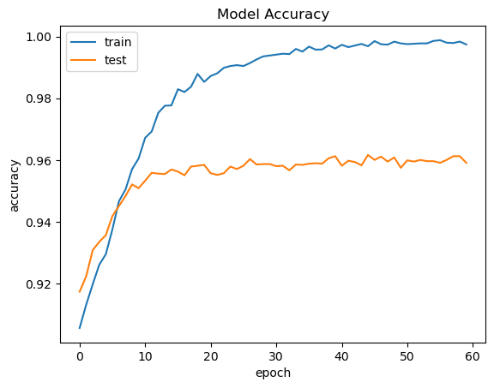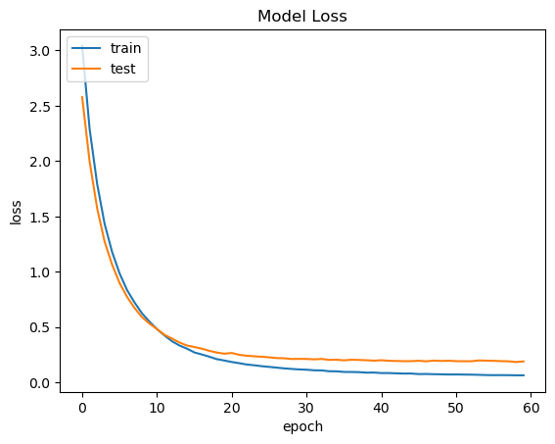

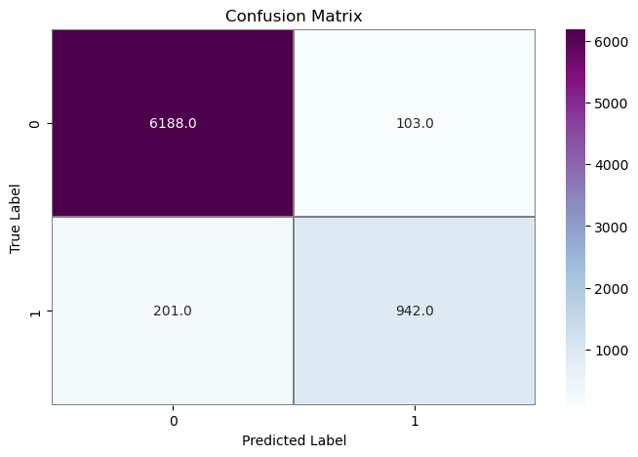

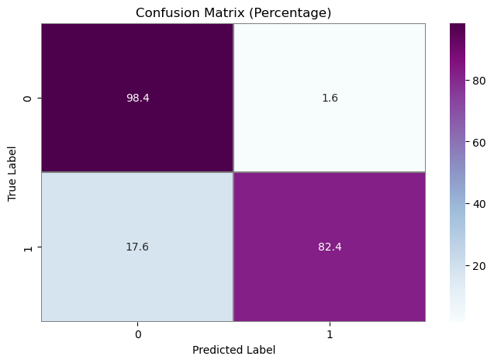

| **Criteria** | **Estimation** |
| --- | --- |
| Accuracy | 0.9585 |
| Sensitivity | 0.9544 |
| Specificity | 0.9554 |
| F1 | 0.9667 |

**Future Works:**

1. **Multi-Modal Integration:** Explore the integration of multiple imaging modalities, such as mammography, ultrasound, and magnetic resonance imaging (MRI), to create a more comprehensive and robust breast cancer detection system. Investigate how EfficientNet can be adapted to handle diverse data sources effectively.
2. **Transfer Learning and Fine-Tuning:** Investigate the potential of transfer learning and fine-tuning EfficientNet on larger and more diverse datasets. This could involve pre-training on a broader range of medical images or utilizing transfer learning techniques from related tasks to further enhance the model's ability to generalize.
3. **Explainability and Interpretability:** Enhance the interpretability of the model's predictions by incorporating explainability techniques. This could involve integrating attention mechanisms or generating saliency maps to highlight regions of the image that contribute most to the classification decision, providing insights for medical professionals.
4. **Clinical Validation and Deployment:** Conduct extensive clinical validation studies involving collaboration with medical professionals to assess the real-world impact of the proposed model. Address concerns related to ethical considerations, regulatory compliance, and the integration of the model into clinical workflows.
5. **Handling Imbalanced Datasets:** Investigate techniques to handle imbalanced datasets, which are common in medical imaging. Implement methods such as oversampling, undersampling, or utilizing advanced loss functions to mitigate biases introduced by imbalanced class distributions.

**Conclusion:**

This paper’s goal was to detect breast cancer using Convolutional Neural Network and Breast Cancer histopathology images as a dataset. In our proposed framework, we used EfficientNet B2 that is a pre trained model. By using the EfficientNet B2 framework, we were able to come out with better results than existing CNN architectures that were used on histopathology images. In this framework, the images were resized, cropped, and augmented to further enhance the training accuracy of the system.As seen in the ResNet-50 obtained an accuracy of 94.33% for cancer detection which is less compared to EfficientNet. We see that in order to scale up efficiently all the dimensions of width, perseverance and depth of the image should be scaled together with an optimal balance and not just scaled individually. The proposed system can be extended to classify the different stages of a breast cancer in the future.